**Artifact Description**

The artifact is an Android weight tracker app that was originally developed for an android app development course, with a local SQLite database and local authentication. I transformed it to use a noSQL Firebase DB as well as Firebase Authentication service, that is encrypted as well as online. Additionally, I created a web interface that allows users to see the top weight losers as well interact with the data by data, and see weight trends.

**Justification for Inclusion**

I selected this enhanced Android weight tracker app for my ePortfolio because it demonstrates my ability to modernize an application database and make it suitable for scale.

* Cloud Integration: Migrating from a local SQLite database to Firebase Cloud Firestore.
* NoSQL Database Design: changing the data structure for a NoSQL environment as well as setting up the project database for scale, since NoSQL databases tend to be more suitable for that out of the box.
* Security Implementation: Utilizing Firebase's security features to ensure data privacy and that data is encrypted in flight as well as in store.
* real-time database: implemented functionality to improve collaboration among developers.
* Web Interface: Developed a web dashboard that allows users to visualize and interact with weight data across different dates and users

**Course Outcomes**

This enhanced artifact shows my ability to meet course outcomes that were not met before:

* Creating real-world, user-centered solutions that consider modern industry requirements like scalability, security, and collaboration.
* Illustrating practical problem-solving abilities in managing data structures and database design choices.
* Applying industry best practices to deliver a product that meets user needs effectively and securely.
* Demonstrating the ability to create interfaces for the data, which is always a plus for user experience.

**Reflection**

I learned several valuable lessons:

* Cloud Integration: I gained practical experience in migrating a local database to a cloud-based solution
* NoSQL Database: I learned how to adapt data structures for a NoSQL environment, which was my first introduction to NoSQL, a completely different paradigm.
* Scalability: I learned how does database design and scalability are related.
* Data Visualization: Creating the web interface taught me how to visualize time-series data and provide interactive elements for data exploration

Challenges faced during the enhancement process:

* Data Migration: Transferring data from SQLite to Firestore while maintaining data integrity, also required me to create a new design for my data.
* Security Implementation: Ensuring proper security rules were in place to protect user data in the cloud environment storage.
* Web Development: Integrating the Firebase database with a web framework and creating interactive data visualization components

This enhancement process has improved my understanding of modern mobile app development practices. Cloud definitely felt like a truly modern way of managing the backend. I also learned about scalability in databases in relation to architecture.  
a user signup  
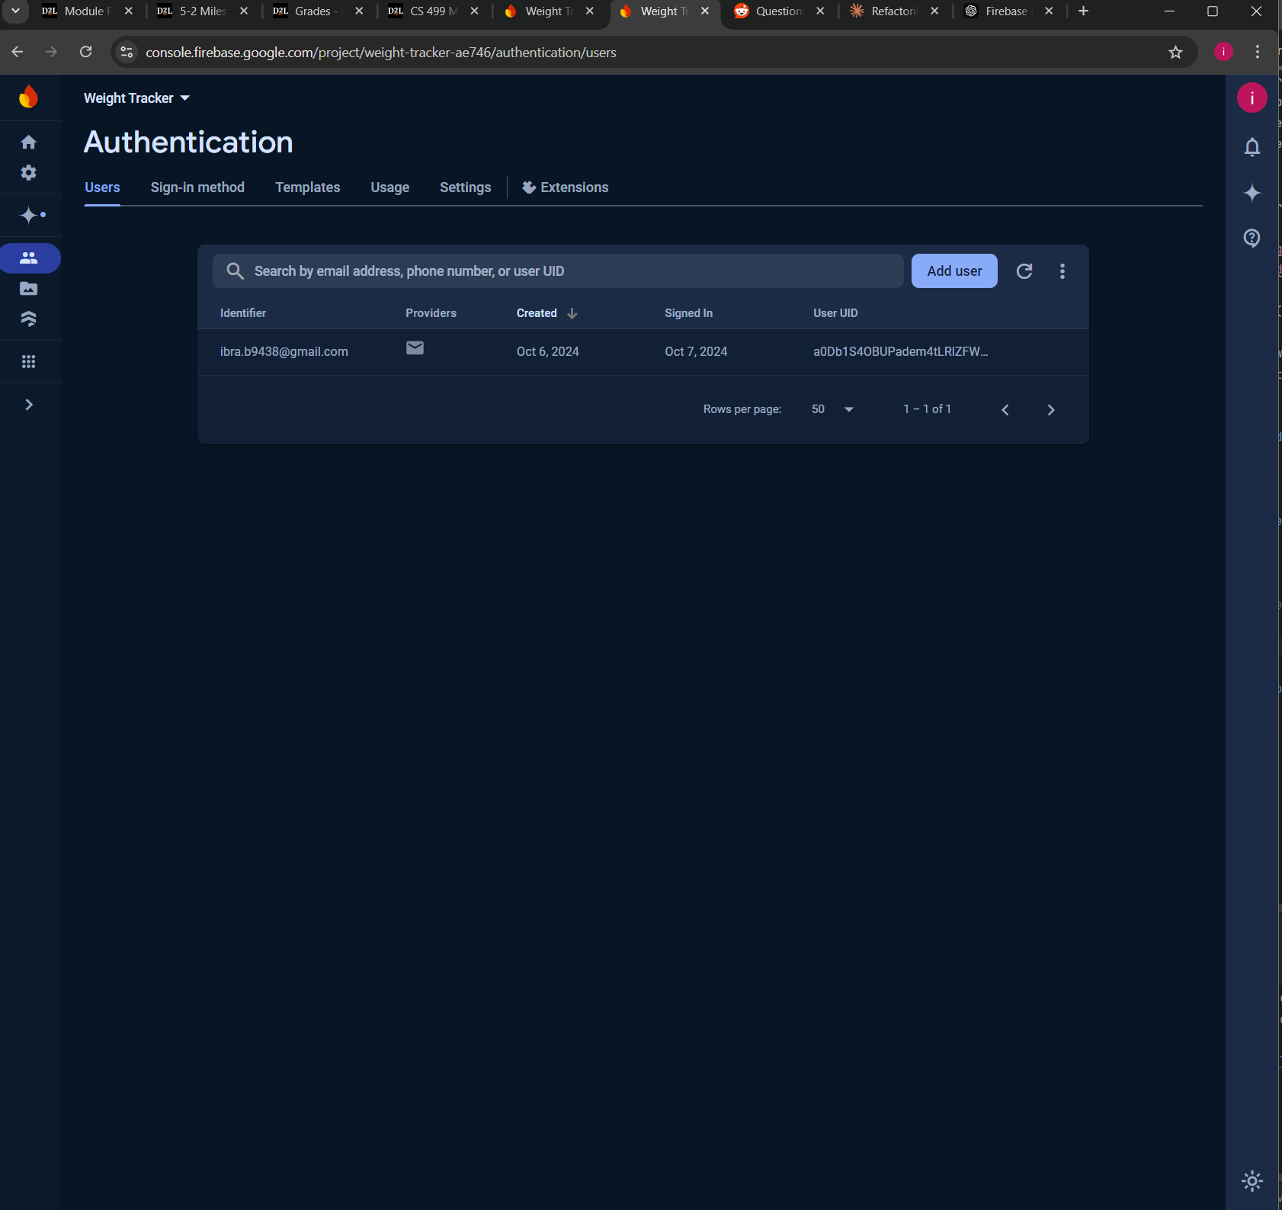

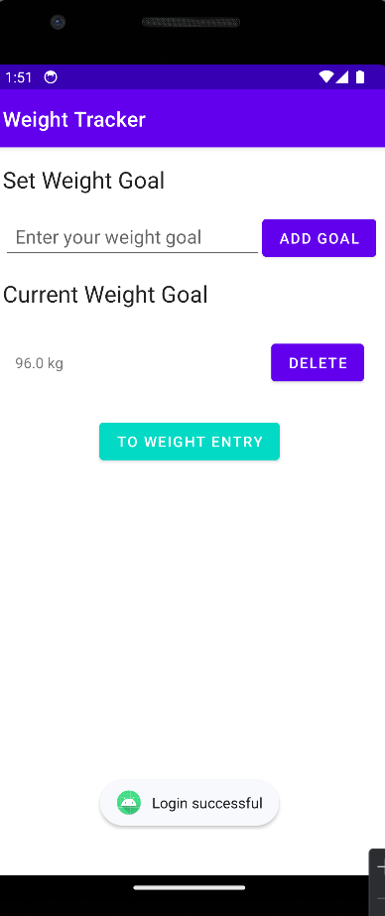 a successful login attempt.

a picture of the database, with an autoID related to the user account, their current weight goal. The app supports multiple users.